K-means clustering algorithm

Introduction

Clustering is an unsupervised learning technique where the aim is to find homogenous subgroups among observations in a data set (James et al, 2013). In K-means clustering, we attempt to partition our observations into a pre-specified number of clusters and have each of the observations assigned to one of these clusters. The goal is to have the variation within the clusters (or the within sum of squares) as low as possible. This variation is measure by squared Euclidian distance. The algorithm will iterate through this process until the observations no longer change between clusters.
In this dataset, our aim was to see if the algorithm could group our 176 different beer styles into groups of ‘similar’ types of beer, i.e. will similar tasting pale ales be grouped together, will dark porter style beers be grouped with similar stouts?
It would be of interest to see if based on the characteristics of the input, whether or not the groups created by the algorithm would be accurate.
Once this clustering algorithm is complete and the results have been analysed, we will attempt to classify the clusters using a classification trees to test the robustness of the groupings. We will conduct the analysis using R Studio software and will utilize several visualisation and clustering packages, including ggplot and rpart.
If a model like this were to be somewhat accurate, it would be a useful sales or marketing tool that the alcohol industry could use to introduce consumers to new beers that they may like, based on these beers being in the same ‘cluster’ or group as beers that the consumer is already known to like.

Preparation of the data

With the outliers having been previously removed at our data cleaning / preparation stage, we are left with 68,854 observations. For the purposes of this algorithm, the data needs to be scaled, as our variables do not have consistent or similar numerical values. If we were to proceed without doing this, we would not be comparing like-with-like. We scaled the data with a mean of zero and a standard deviation of one.
The K-means algorithm requires no dependent variable, however any variables that are included in the algorithm must be of continuous data-type and be suitable for measurement using Euclidean distance. For that reason, we excluded the ‘Efficiency’ and ‘BrewMethod’ variables from the algorithm. The variables that were used were:
- ABV
- IBU
- Color
- BoilGravity
- BoilTime
- MashThickness

Selecting ‘K’

To decide on the number of centers (or clusters) that we will be using for this data, we used the method of generating a scree plot, mapping the within sum of squares totals of the observations against numbers for k. Given that selecting k can be somewhat subjective, we tried a number of different figures. The scree plot ‘elbow’ is generally used as a guide for the correct number, however even this can be very subjective.
In our initial attempt we ran the algorithm with 6 clusters, however the total between sum of squares over total sum of squares was 50.7%, a relatively low reading. As well as that, the observations were not well spread across the clusters with a significant number grouped into one cluster and other clusters having very few observations.
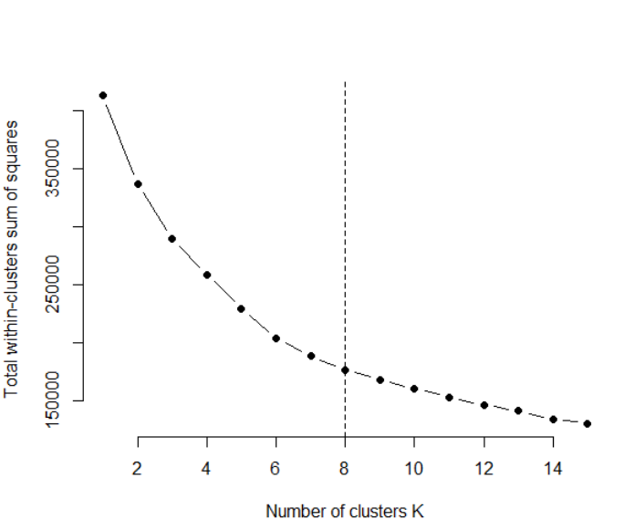
Figure 7 - Scree plot illustrating the 'elbow at k = 8

There were similar results when we tried the algorithm using 7 clusters, however upon further testing, using k = 8 appeared to be the optimum number to use. We came to this conclusion because the observations were relatively evenly spread across the clusters and the ‘elbow’ of the scree plot in Figure 7 is arguably at 8.
This meant our data would be grouped into 8 broad ‘types’ of beer.

K-means Algorithm

Once we had selected our number for k, we could run the algorithm in RStudio. The following is the output that was generated:
K-means clustering with 8 clusters of sizes 1463, 7546, 8971, 5014, 9222, 17606, 3055, 15977
Within cluster sum of squares by cluster:
[1] 13845.92 20648.41 25437.95 24798.06 17253.75 21272.93 23894.75 29052.05
(between_SS / total_SS = 57.3 %)

We can see that there are two clusters that are larger than the others (17606 and 15977 respectively). This is not ideal, however adjusting the k number did little to affect this. We can see in our visualisations in the following section that the algorithm struggles somewhat in grouping certain observations where the differences in their features are not distinct.
Using the ‘factoextra’ library in RStudio, we produced the following cluster plot to visualize or data:

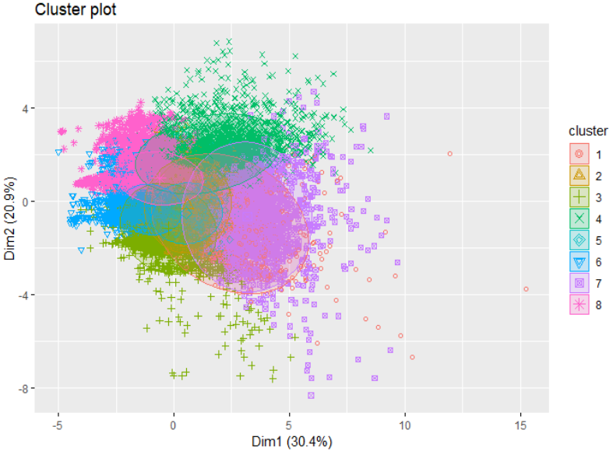
Figure 8 - Cluster Plot

We can see some distinct clusters in certain areas, but also some overlap, reflecting the WSS value of 57.3%.

Visualisations

Next, we will look at some plots to observe any significant clustering when we plot certain variables against each other. The scatterplots on the left show all of the observations together, and on the right, we see the same data, but colour-coded by their K-means cluster. Firstly, we can look at the bitterness versus the colour of the beers:
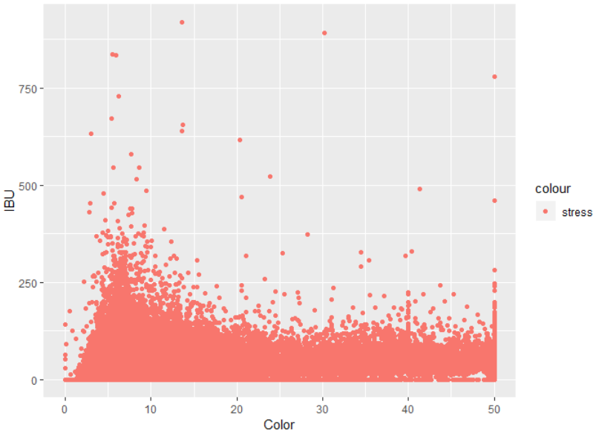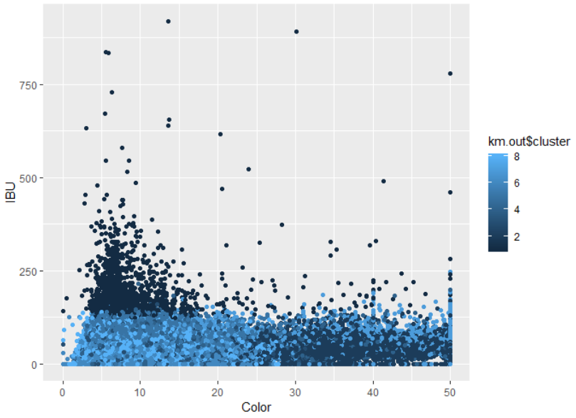
Figure 9 – IBU vs Color
We can see that there is a darker cluster where the bitterness levels are higher (from 100 to 250 approximately). Although this plot has a significant amount of overlapping data, we can see distinct differences in clusters of higher and lower colour levels of the beers.
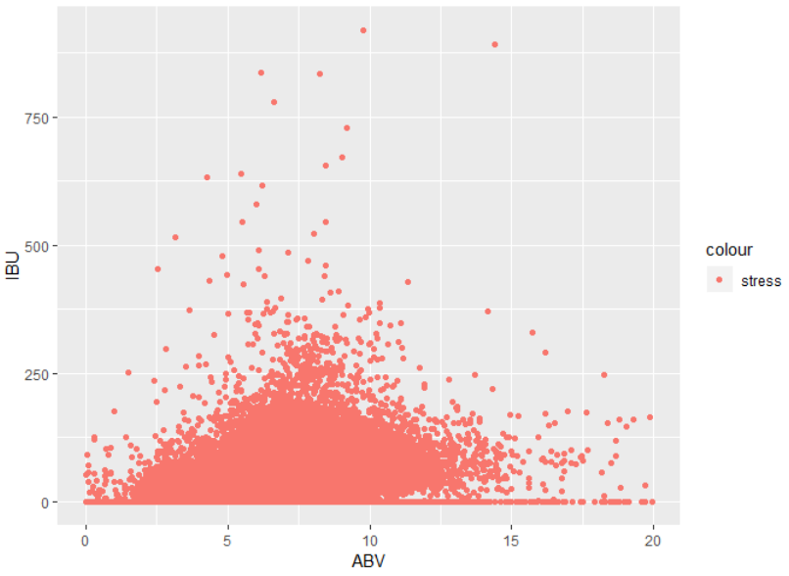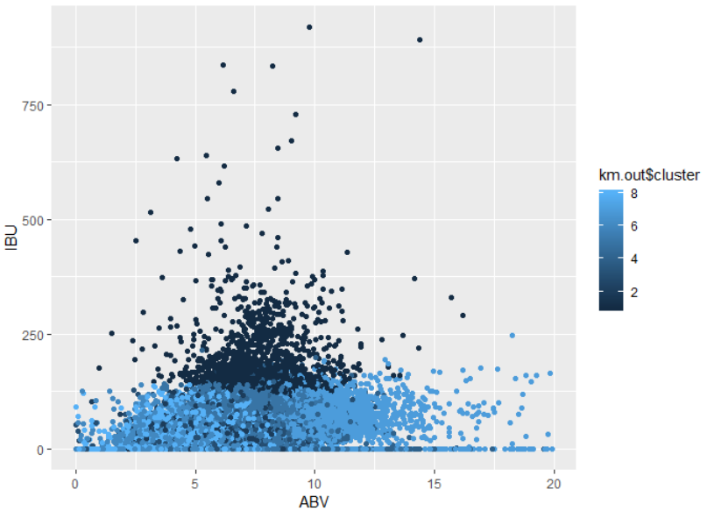
Figure 10 – IBU vs ABV
In Figure 10 we see again the more bitter beers standing out, however the higher alcohol beers also have their own distinct light-blue cluster.
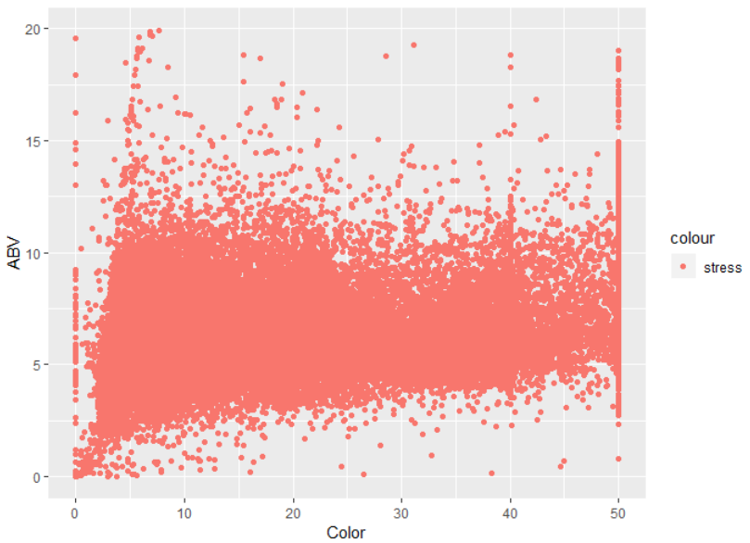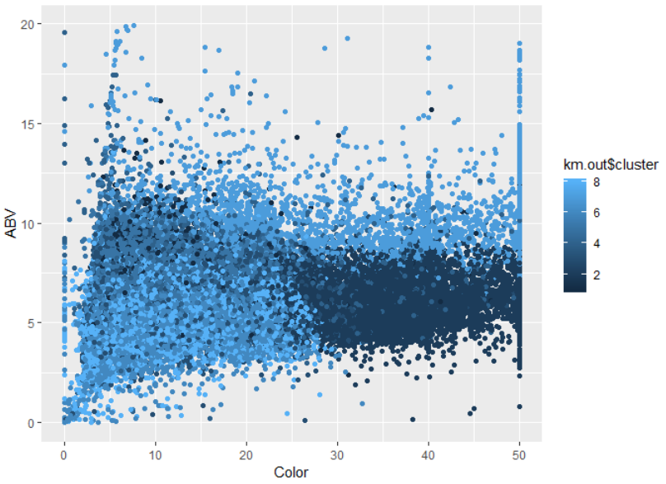
Figure 11 – ABV vs Color
Further to what we had previously seen, Figure 11 displays a cluster of high-colour (dark), high alcohol content beers in a light blue colour.

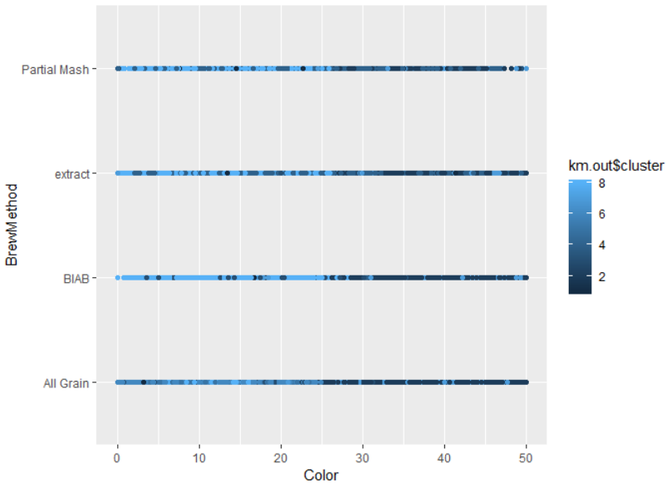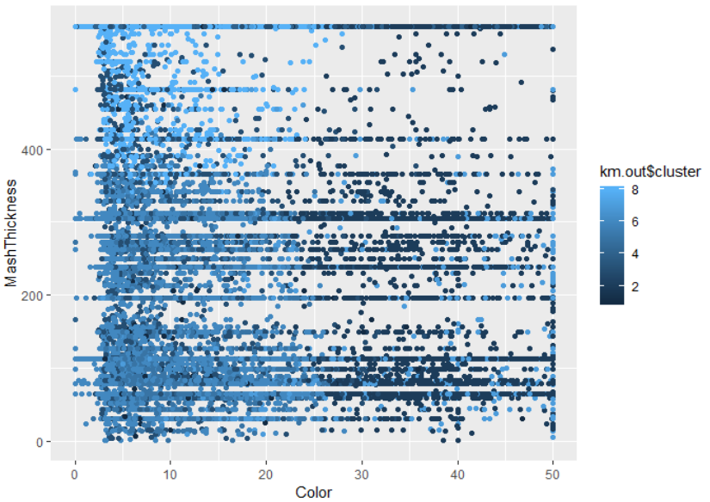
Figure 12 – Color vs BrewMethod and Color vs MashThickness
Figure 12 shows the colours of the clusters across different brew methods and mash thickness. Again, we can see some distinction between clusters.

Extracting the clusters

The table in Figure 13 shows a summary of some highlighted mean values of variables in the clusters:

Cluster number | ABV | IBU | Colour
Cluster 1 | 7.724 | 194.8 | 9.621
Cluster 2 | 6.091 | 41.72 | 36.73
Cluster 3 | 5.906 | 35.34 | 9.355
Cluster 4 | 6.502 | 43.56 | 13.21
Cluster 5 | 7.212 | 67.73 | 9.398
Cluster 6 | 5.191 | 29.57 | 8.406
Cluster 7 | 10.43 | 65.33 | 33.84
Cluster 8 | 5.515 | 37.53 | 8.68
Figure 13
Whilst some clusters are distinctly different, for example cluster 1 is very different to cluster 3, we can see some clusters are reasonably similar in their characteristics.
We can observe each of the clusters in the plots in Figure 14, where we have mapped Alcohol by volume against Colour, to visualise similarities and differences in the clusters. The observations are all mapped on the same scale:
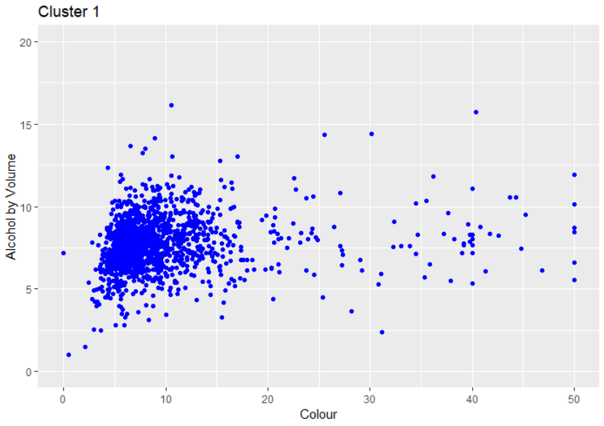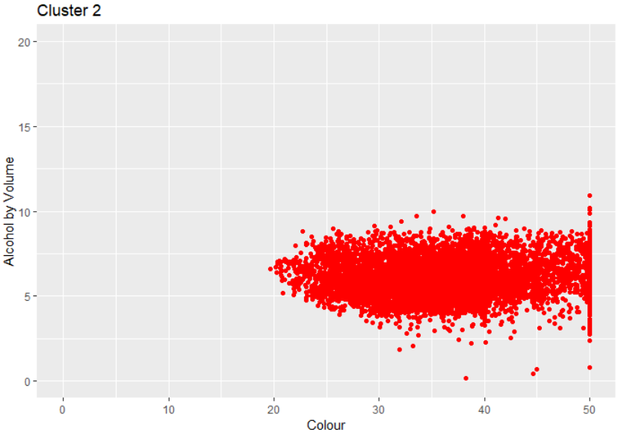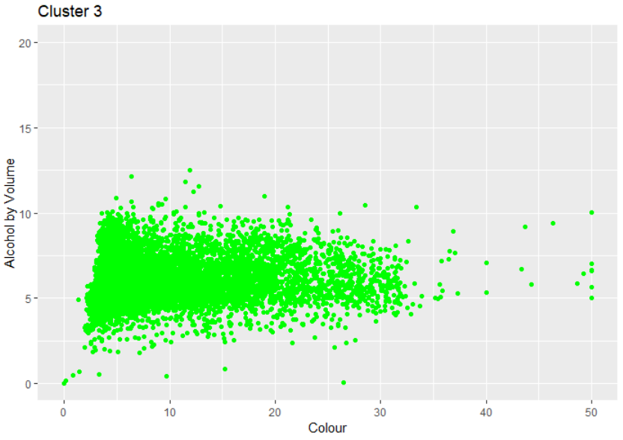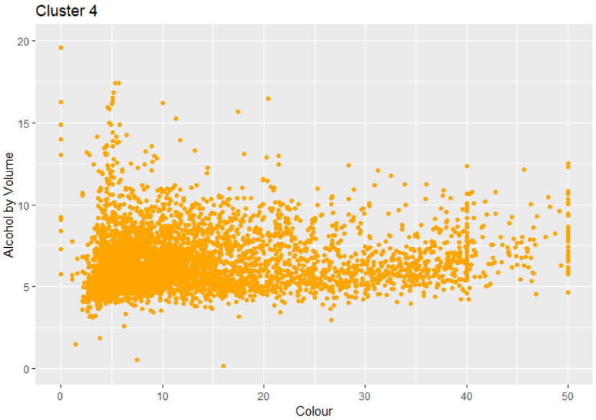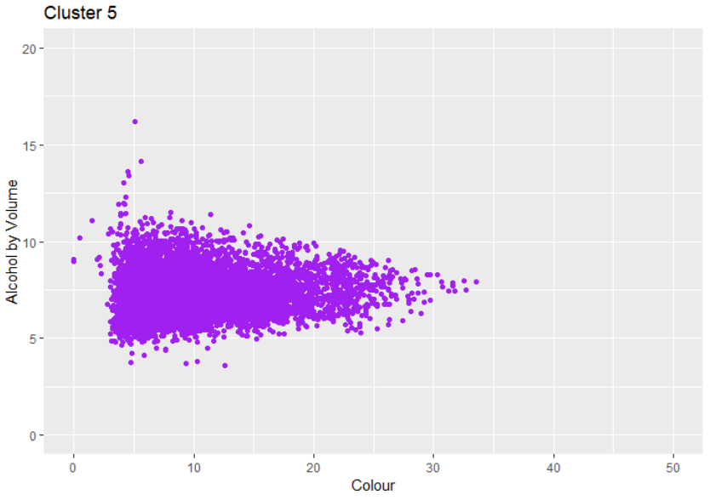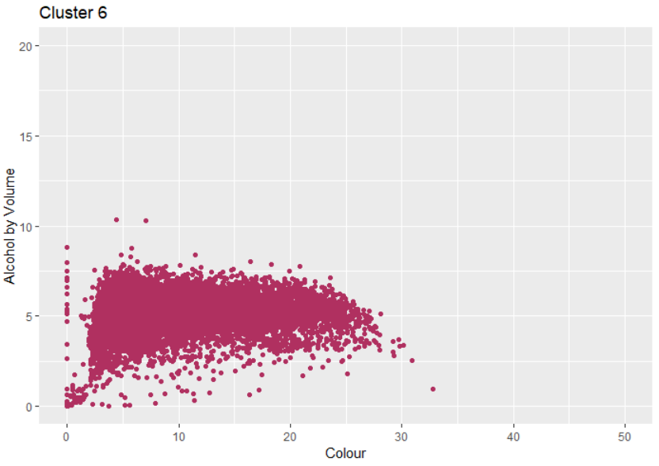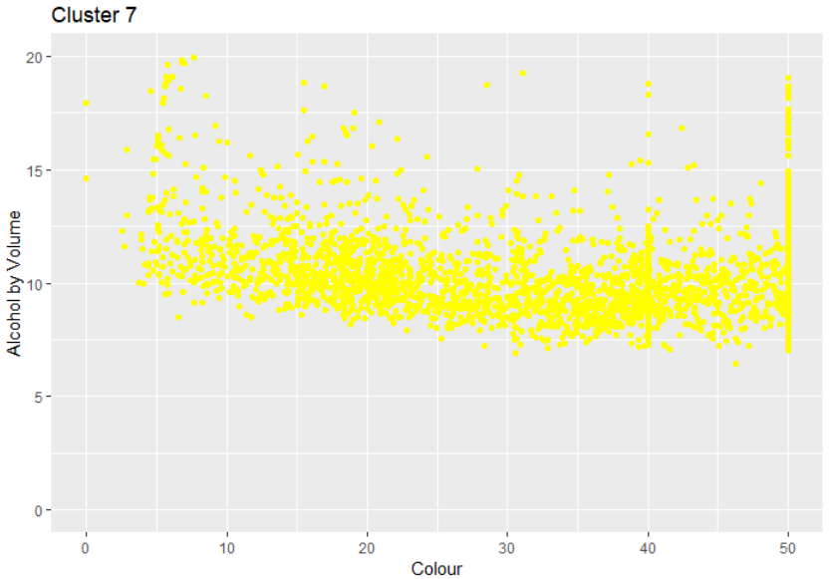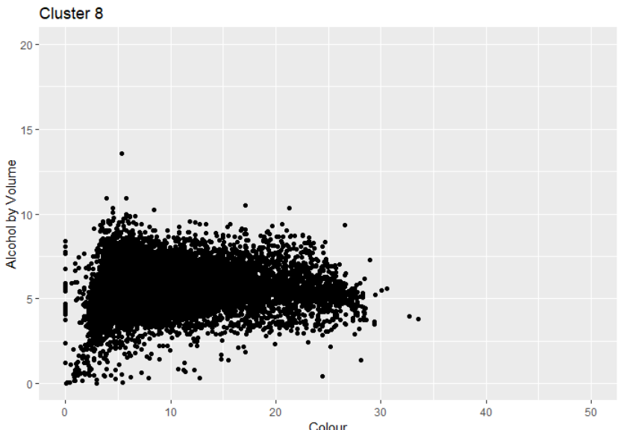
Figure 14

We can take a further look and see what types of beers have been clustered together by running random samples of particular clusters in RStudio. Figure 15 is a random sample from cluster 2:
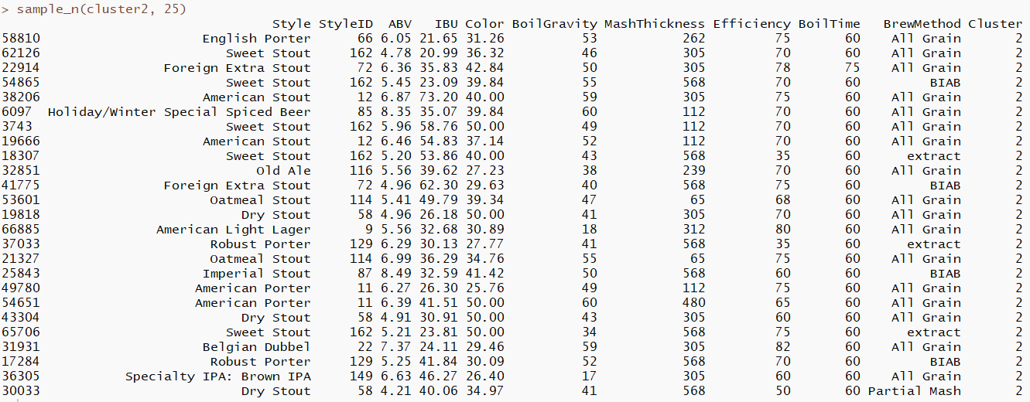
Figure 15
From this random selection, we can see from the ‘Style’ column that the algorithm appears to have relatively accurately clustered Stouts and Porters together, as we would have anticipated since they are similar beer types.
Similarly, when we look at the cluster of beers in cluster 1 (Figure 16), we can see that beer styles with high bitterness (mainly IPAs) have been grouped together:
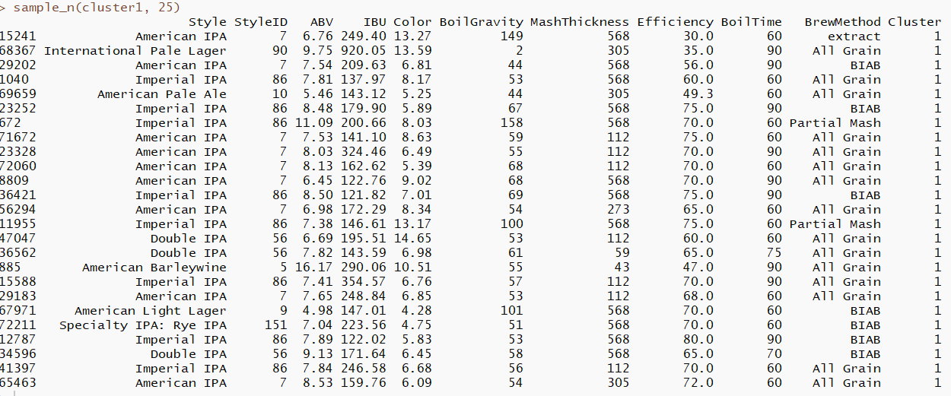
Figure 16

It is important to note that the algorithm has not grouped all American IPA style beers from the dataset into this cluster together. Instead, it has grouped the IPAs into different categories based on differing characteristics. Features such as the bitterness and alcohol levels of American IPA style beers in the dataset vary drastically, so it is logical that different types of the same ‘style’ are grouped into different clusters when this variation occurs.

Classification and evaluation of the clusters

To evaluate the performance of this K-means algorithm we will use a both a Decision tree and Random Forest Classifier. Based on their characteristics and features, we have named each of the eight clusters with a domain specific name, each one providing a general description of the type of beer in that cluster. Each cluster can then be used as a categorical variable for classification. The classes are:
- Very Strong Bitter
- Stout
- Medium Ale
- Special Ale
- Strong Bitter
- Light Beer
- Extra Strong
- Light-to-Medium

Decision Tree

The Decision tree algorithm works by minimizing entropy and segmenting our data into binary regions. A benefit of using this model is that it produces an easy-to-interpret tree where we can visualise our classification in a similar way that we view a flowchart.
To create the Decision Tree, we first split our data into training data (50%) and validation data (25%) and fit a classifier to the training data, using ‘Cluster’ as our class. We can view the results in the initial classification tree in Figure 17:
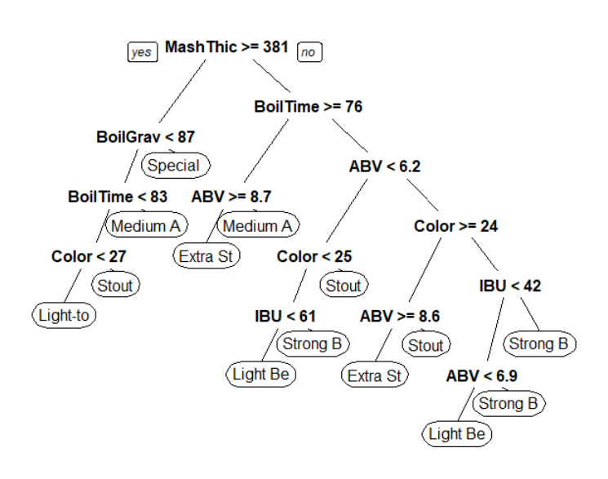
Figure 17 - Decision Tree
To take just two examples, we can see from this tree that parameters for a beer to be classified as a Medium Ale are:
- MashThickness >= 381, BoilGravity < 87, BoilTime > 83, or
- MashThickness < 381, BoilTime >= 76, ABV < 8.7
The parameters for a beer to be classified as a Light Beer are:
- MashThickness < 381, BoilTime < 76, ABV < 6.2, Color < 25, IBU < 61, or
- MashThickness < 381, BoilTime < 76, ABV > 6.2, Color < 24, IBU < 42, ABV < 6.9
Next, to check the accuracy of the classifier, we firstly needed to classify all observations, before then generating a table for the validation data only. The results are in Figure 18:

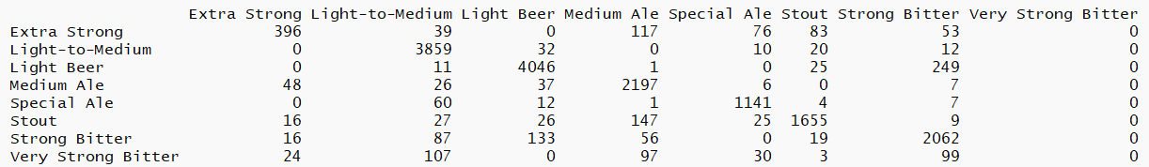
Figure 18
From the data in this table, we can calculate that the accuracy of the model is 0.8921164, or 89%.
This means that 89% of observations were classified correctly in the model. We can see however that algorithm has ‘misclassified’ or grouped all of the observations that should have been in the ‘Very Strong Bitter’ cluster into other similar clusters (mainly into ‘Strong Bitter, Light-to-Medium, and Medium ale).
We will see if the Random Forest algorithm can classify these observations more accurately.

Random Forest

The Random Forest algorithm is based on the same concept as the Decision Tree, however it uses different subsets of the data to create many decision trees and by doing this reduces overfitting. It is therefore an ensemble algorithm that can also measure which are the most important variables in our dataset. A reason that the Random forest algorithm is more useful to us than the decision tree is that it reduces the effect of the most dominant variables, creating diversity and a more generalised model. To achieve this, the algorithm is typically run 500 times.
When we run the random forest algorithm on our data, using the ‘Clusters’ variable as our class, we can see that the out of Bag (OOB) error rate of 1.85% is low, suggesting a high level of accuracy of this classification. We can see this in detail in the Confusion Matrix table below, generated from RStudio:
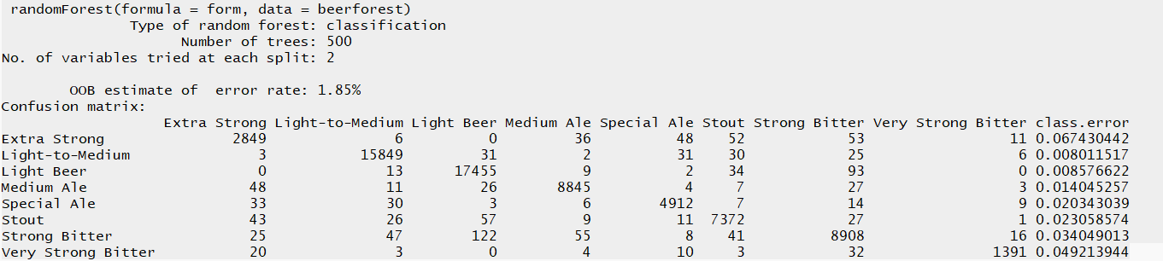
Figure 19 – Confusion Matrix

The importance of each of the variables that we used in the algorithm can be seen in Figure 20. We can see that ‘MashThickness’ was in fact the most important predictor for beer clusters. Bitterness is shown to be the least important.

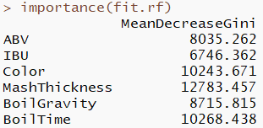
Figure 20
These figures regarding variable importance can be visualised more easily in Figure 21: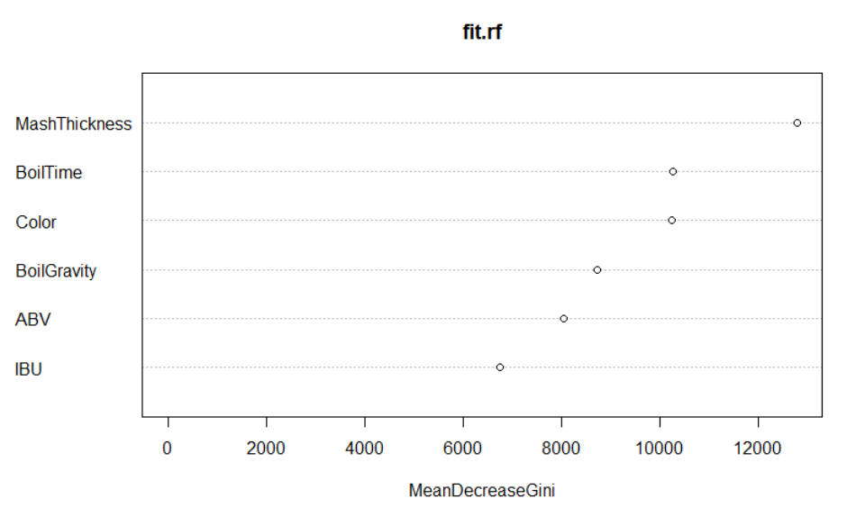
Figure 21
The Mean Decrease Gini Index reflects how each variable relates to the purity on each node, the higher the value the more significance the variable has.

